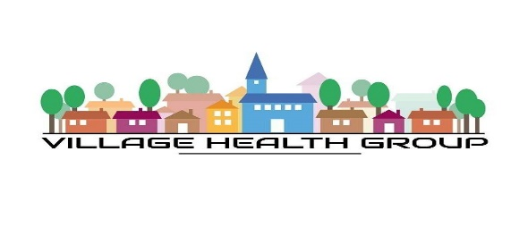

Patient guide to submitting an online request

Village Health group will be open for medical queries 8am and 2pm

- Go to Village Health Group Website

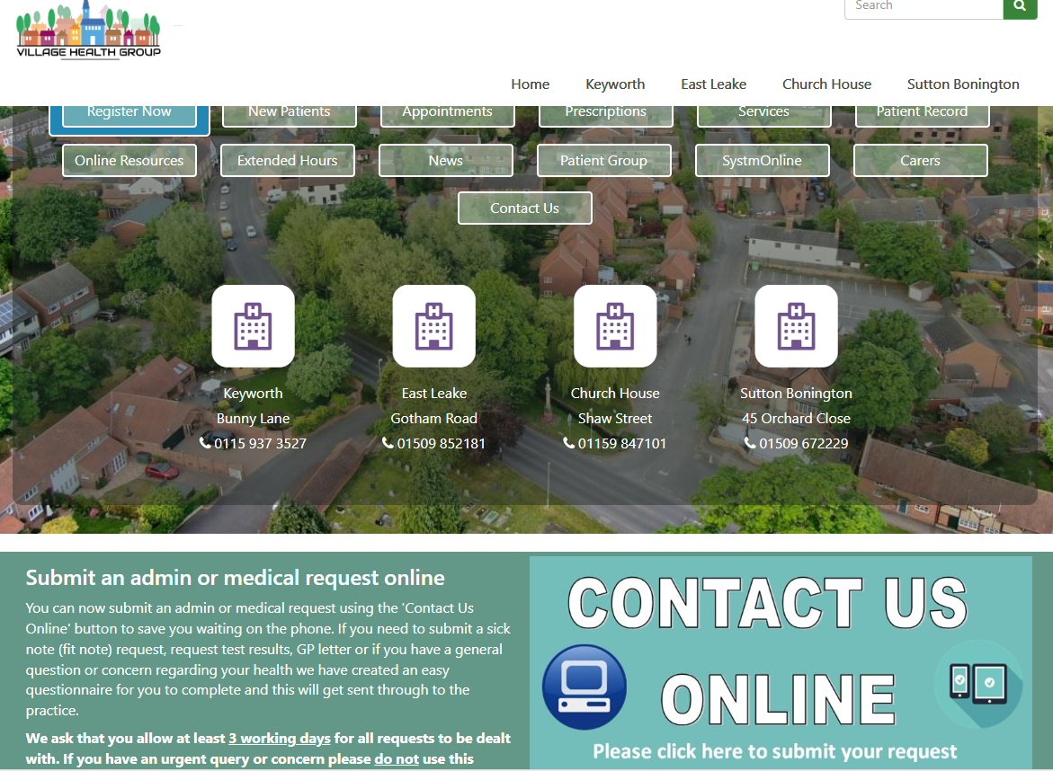

- Select contact us online

- Go to next page

- Select the relevant reason that you wish to contact the practice.
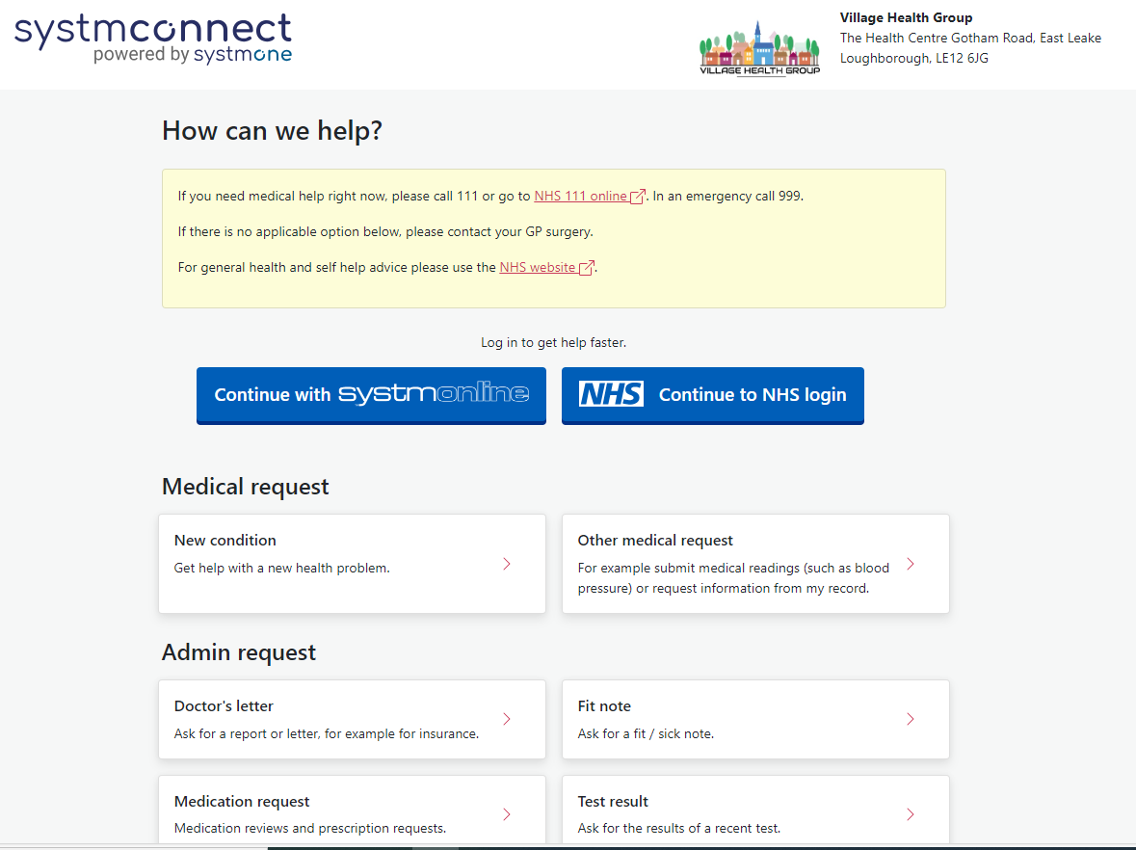

- You will be asked to confirm your situation is not an emergency
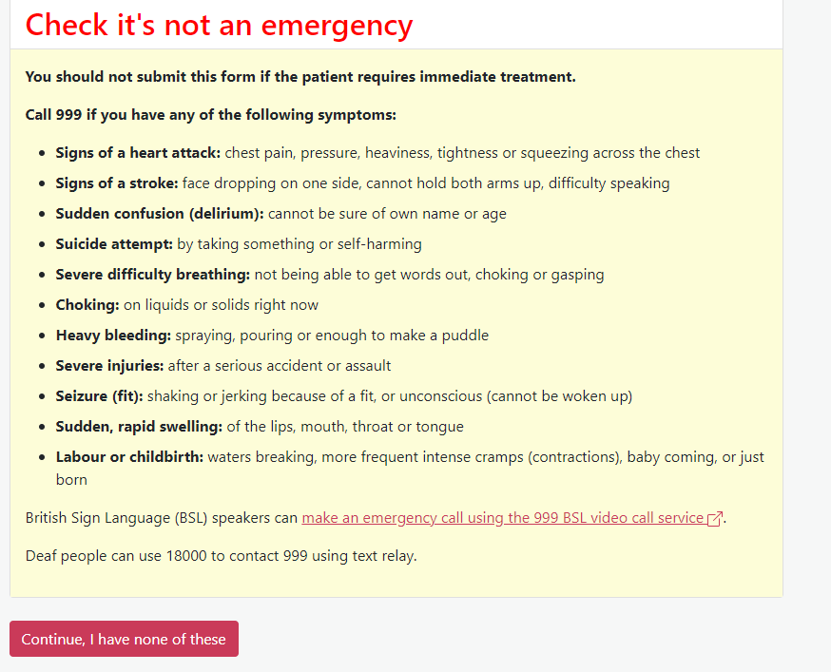
- You will then be asked to provide details of your condition/request and select next
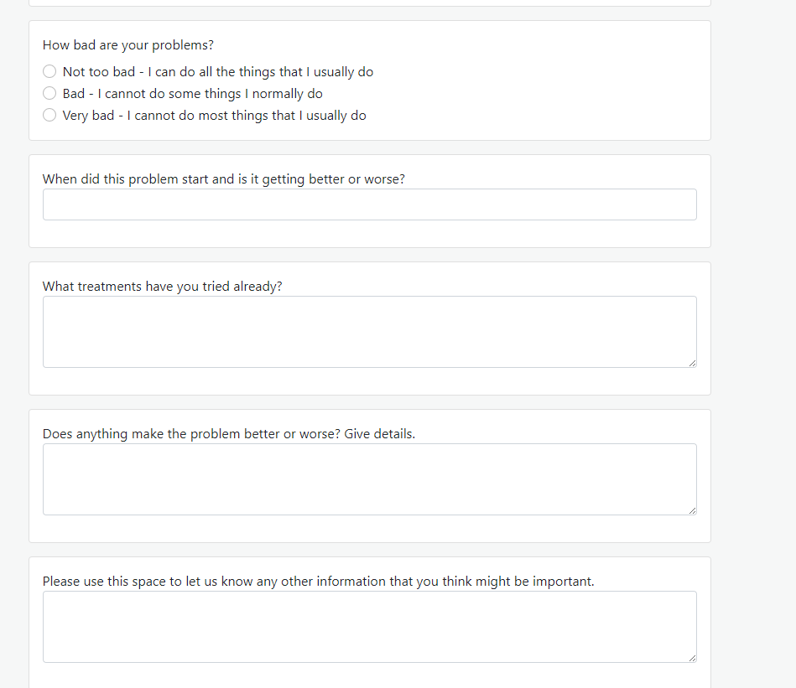

- You will then be asked to complete your details
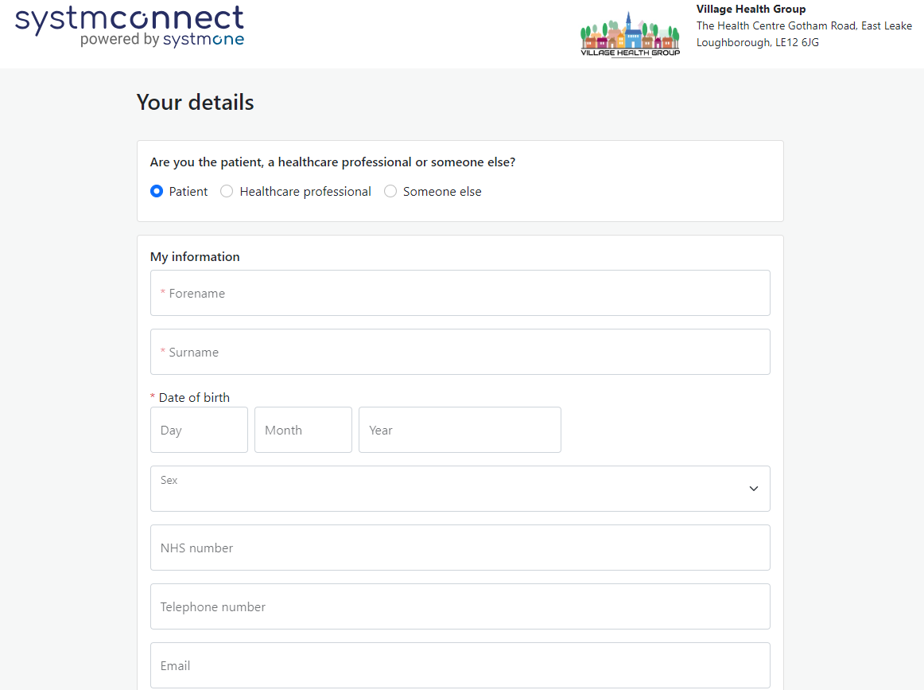

When a medical query is received, the GP team will review each request that working day to determine how best to meet your needs

You will then be contacted with either an online response if this is suitable or a link to book a date & time for a face to face or telephone appointment

For urgent medical queries we will respond to you that working day.

For routine medical queries & administrative queries we will respond to you within 3 working days

Thank you, Village Health Group.

